
Dashboard Design

Date | 1 November 2026
Team ID
Project Name | EV Market Performance & Insights Platform
Maximum Marks | 5 Marks

Activity 1: Interactive and visually appealing dashboards
Creating an effective Streamlit dashboard involves presenting business data stored in Snowflake through clear, interactive, and easy-to-understand visualizations. Students should design the dashboard so that users can quickly understand important KPIs, trends, comparisons, and business insights.
- Clear and Intuitive Layout
- Use Appropriate Visualizations
- Colour and Theming
- Interactive Filters and Slicers
- Drill-Down Capabilities
- Responsive Design
- Custom Visuals and Icons
- Use of Infographics

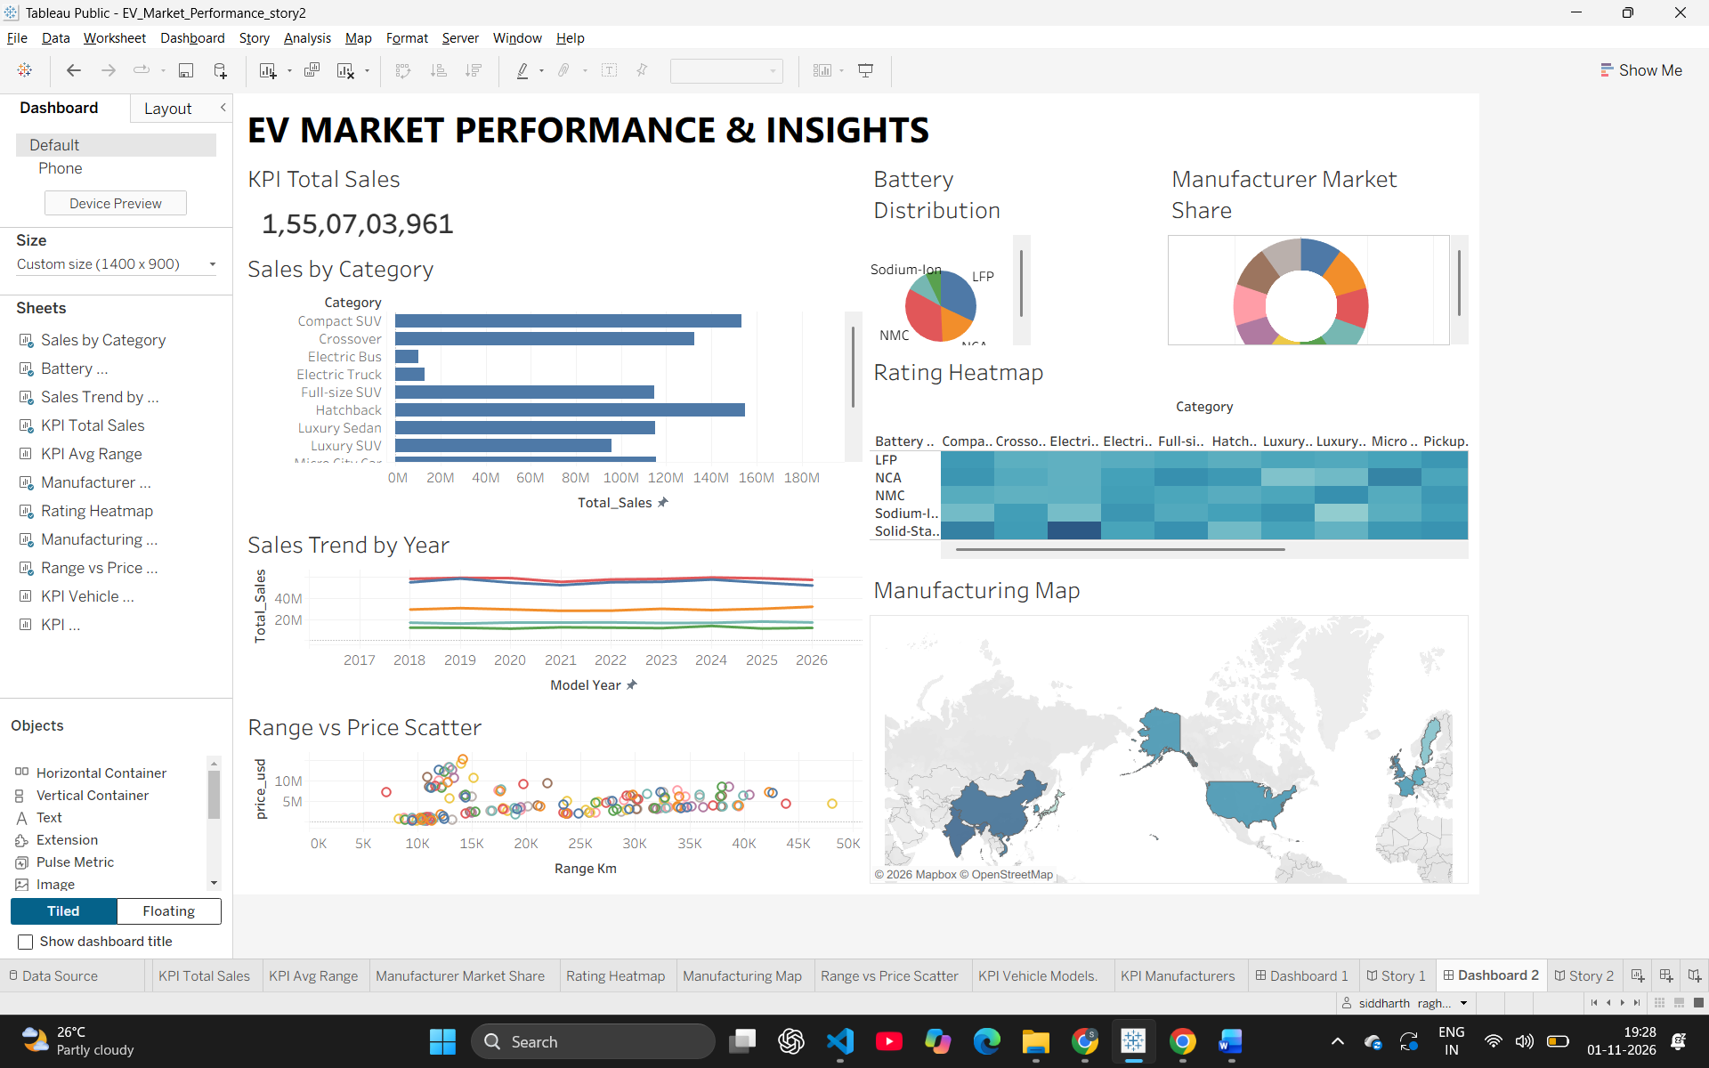
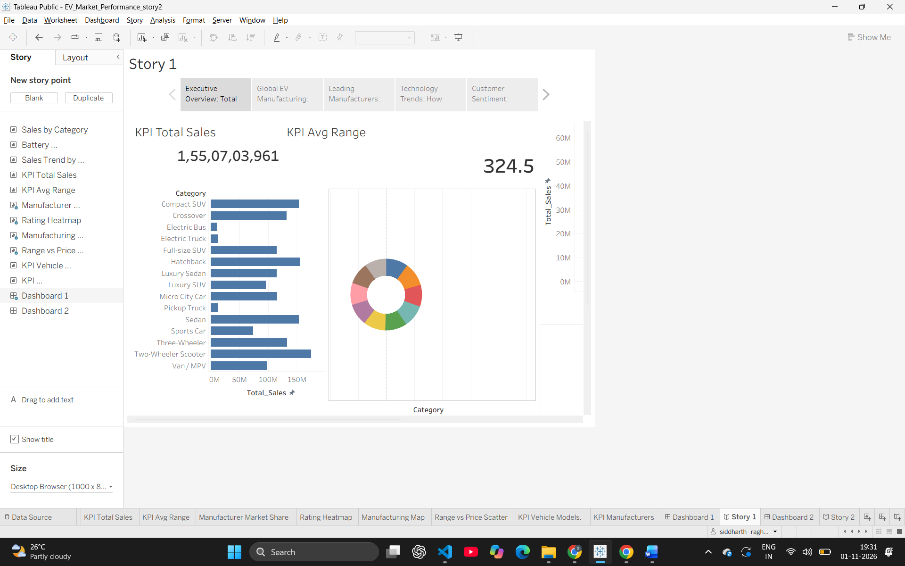
Note: Highlight the major outcomes in form of bullet points
Outcomes from the EV Market Dashboard:
- Compact SUVs dominate the overall EV market volume:
The "Sales by Category" horizontal bar chart clearly indicates that the Compact SUV segment generates the highest total sales by a significant margin, followed by Hatchbacks and Luxury SUVs, indicating strong consumer preference for practical, mid-sized electric vehicles.
- LFP and NMC battery technologies hold the majority market share:
The "Battery Distribution" pie chart and the "Rating Heatmap" reveal that Lithium Iron Phosphate (LFP) and Nickel Manganese Cobalt (NMC) are the most widely adopted battery technologies across most vehicle categories, while alternatives like Sodium-Ion and Solid-State currently represent a smaller fraction.
- Global EV sales have shown a consistent upward trajectory:
The "Sales Trend by Year" line chart demonstrates a clear and continuous year-over-year growth in total sales volume from 2017 through to the 2024-2026 projections, highlighting the rapid maturation and mass adoption of the EV market.
- Manufacturing is heavily concentrated in key global regions:
The "Manufacturing Map" visually confirms that EV production is concentrated in specific geographic hubs—most notably the United States, China, and parts of Europe—which is crucial for understanding global supply chain dynamics and market dependencies.
- A strong correlation exists between vehicle range and price:
The "Range vs Price Scatter" plot reveals distinct clusters. While there is a general upward trend (higher range equates to a higher price), there are also outliers, indicating budget-friendly long-range models competing against premium short-range vehicles.
Overall Outcome: The dashboard provides a comprehensive, 360-degree view of the EV market. It demonstrates that the industry's rapid growth is primarily driven by Compact SUVs and specific battery technologies (LFP/NMC), with manufacturing heavily localized to a few key countries.

